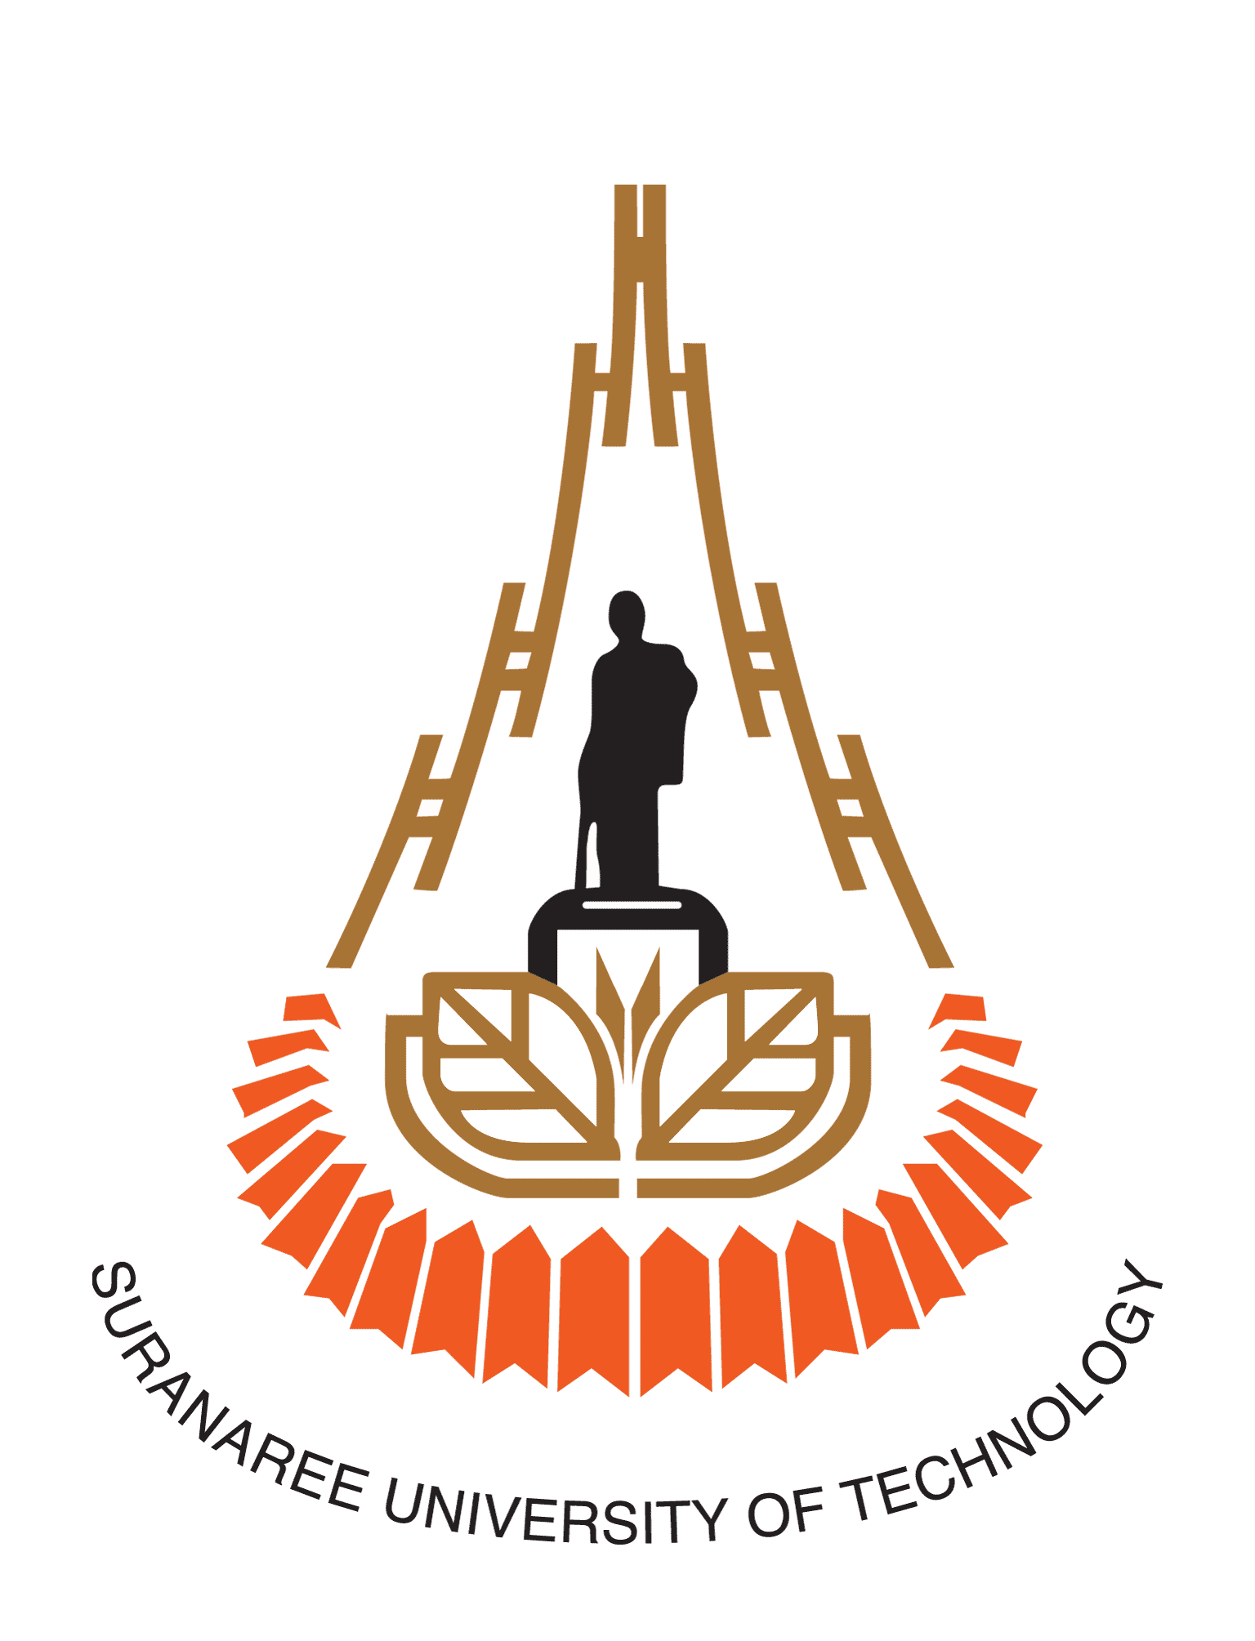

LOGO
Memorandum of Understanding
Between
Suranaree University of Technology, Thailand
And
[NAME OF PARTNER INSTITUTION], [Country]

Suranaree University of Technology (hereinafter referred to as “SUT”) located at 111 University Avenue, Suranaree Sub-District, Muang District, Nakhon Ratchasima, THAILAND and [NAME OF PARTNER INSTITUTION] (hereinafter referred to as “……”) located at [ADDRESS OF PARTNER INSTITUTION] agree to enter into the following Memorandum of Understanding (MOU) to promote and facilitate joint educational and cultural collaboration. The two institutions also agree as follows:

I: Purpose of the MOU

The purpose of this MOU is to promote and facilitate collaboration in undergraduate and postgraduate education, scientific research and exchange of students, faculty and staff between SUT and [NAME OF PARTNER INSTITUTION].

II: Scope of Collaboration

The areas of collaboration can be proposed by either institution and can include, but not limited to:

- Joint degree programmes;
- Joint teaching and research;
- Joint seminars, symposiums and conferences;
- Mobility of faculty members, staff and researchers between institutions;
- Mobility of students between institutions;
- Staff professional development;
- Sharing and creation of educational materials and resources;
- Joint cultural activities; and
- Other collaboration and exchange as mutually agreed by both institutions.

III: Financial Arrangement

Both institutions agree that all specific arrangements and plans for activities are to be negotiated and are dependent on the availability of funds and the approval of each institution’s authorised representatives.

IV: Agreement of Implementation

Any specific activities developed under this MOU shall be detailed in the Agreement of Implementation, which will be signed by each institution’s authorised representatives.

The Agreement of Implementation will include such items as:

- Elaboration of the responsibilities of each institution for the agreed upon activity.
- Schedules for specific activities.
- Budgets and resources of financing for each activity.
- Any other items deemed necessary for the efficient management of the activity.

V: Duration and Termination

This MOU shall be signed by authorized representatives of both institutions and will be in effect for a period of [NUMBER OF YEARS] years from the last date signature. This MOU may be terminated by either institution giving written notice to the other at least [NUMBER OF DAYS] days prior to the proposed termination date.

Amendments to this MOU may be requested, in writing, by either institution. Any amendments shall be approved by authorised signatories.

In the case that any content contained in further agreement conflicts with any content in this MOU, the content in this MOU shall prevail.

VI: Governing Law

This MOU shall be governed by and construed in accordance with the laws of Thailand.

VII: Notices

- All notices to be given under this MOU shall be in writing and shall be deemed to be delivered and received by any mean as follows:

SURANAREE UNIVERSITY OF TECHNOLOGY
Address : 111 University Avenue, Suranaree Sub-District, Muang District,
Nakhon Ratchasima, THAILAND
Coordinator : [NAME] [Position]
Telephone no. :
Email :

[NAME OF PARTNER INSTITUTION]
Address :

Coordinator : [NAME] [Position]
Telephone no. :
Email :

- Any change of information above shall be promptly informed to the other party.

This MOU is prepared in English. Two original copies of this MOU are produced and authentic. In witness whereof, the SUT and [NAME OF PARTNER INSTITUTION] have caused this MOU to be effective by their duly authorised representatives.

For Suranaree University of Technology  Signature  (Assoc. Prof. Dr. Weerapong Pairsuwan)  Rector  Suranaree University of Technology  Date:  Witness  (.................................................................)  Dean, Institute of ………. | For [Name of Partner Institution]  Signature  (.................................................................)  [Rector/President]  [Name of Partner Institution]  Date:  Witness  (.................................................................)  [Position]

Updated as of 23 February 2021

